Transactions Analysis Report

Name: Ayesha Ashraf

Ayeshaashraf015@gmail.com

Table of contents
- Introduction
- Dataset Description
2.1 Variables Description
- Data Preparation
- Regional Analysis
- Transaction Type Analysis
- Customer-Level Analysis
- Time-Based Analysis
- Visualizations
- Key Findings
- Limitations
- Conclusion
- Appendix
  - R code

Introduction
This report presents an exploratory data analysis of a transaction dataset using the R programming language. The objective of the analysis is to understand transaction patterns across regions, customers, transaction types and time.

Dataset Description
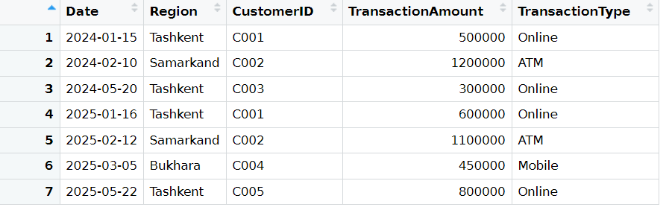
- This dataset contains 5 variables and 7 transaction records.
- Date is in y-m-d format and is the day the transaction happened
- Customer-id is a unique identifier for each customer
- Region shows where the transaction occurred
- Transaction-Amount shows the monetary value of the transaction
- Transaction-Type is the mode of transaction (online, ATM, mobile)

Data Preparation

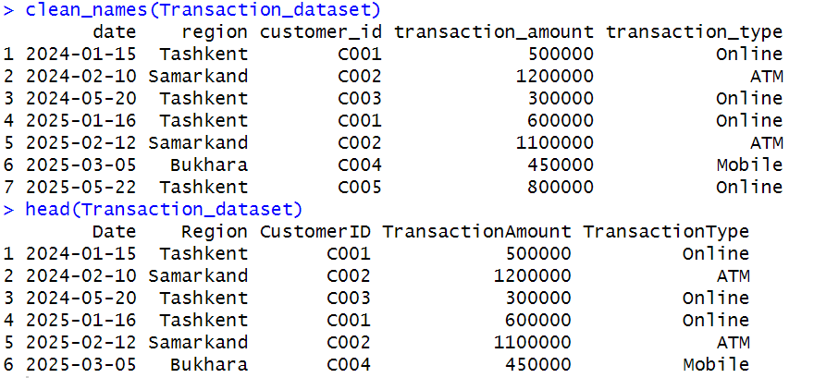
Before analysis, the dataset was cleaned and prepared in R. The Date variable was converted into proper date format and categorical variables such as region and transaction-type were converted into factors.

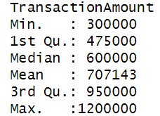
Descriptive Statistics:

The mean value being higher than the median indicates a right-skewed distribution. This suggests that a small number of high-value transactions increase the overall average.

Key metrics
Total transaction amount: 4950000
Average transaction amount: 707142.9
No. of rows: 7
No. of columns: 5

Structure of the dataset:

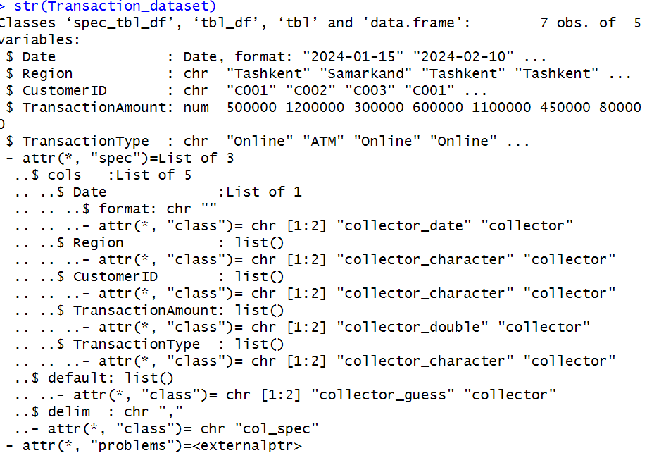

Regional Analysis
Transaction-Amount by Region
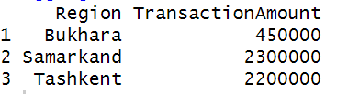
Tashkent appears to be the most active transaction region. Samarkand, despite fewer transactions, shows relatively higher transaction values. Bukhara’s low activity may indicate limited customer representation.
Transactions trend by region
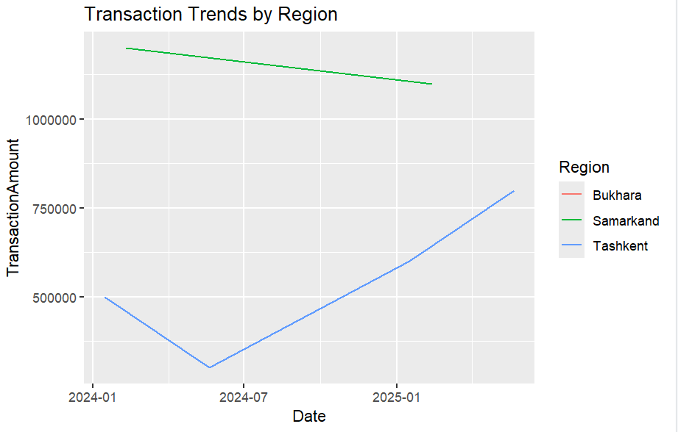

- The transactions dropped between January and May and then continued to increase after July in Tashkent.
- The transaction declined in Samarkand.
- The transactions are not shown for Bukhara.

Transaction-Type Analysis

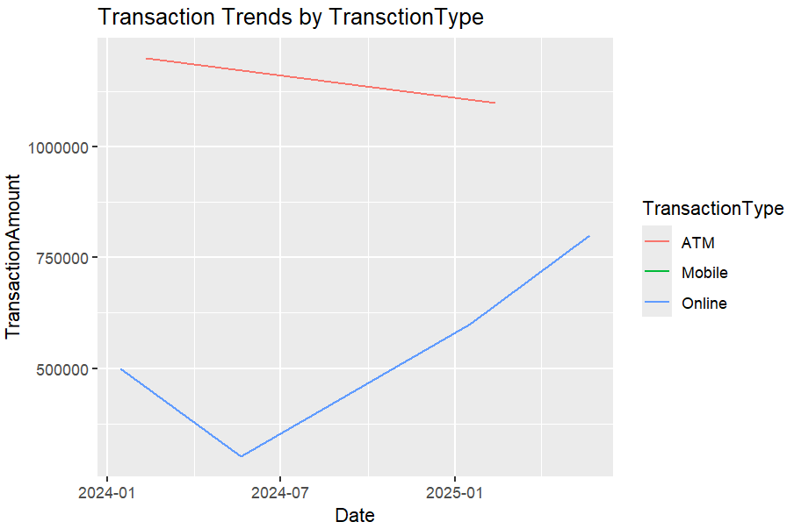

The line graph illustrates three transaction types which are Online, ATM and Mobile. Online transactions dropped between January and June in 2024 and then accelerated after July in 2024 and continued to do so even after 2025, however, ATM transactions dropped between January 2024 and January 2025. There were no transactions through mobile.

Key takeaway:
As technology has become a primary driver, the world is shifting to online payment methods and the era of paper cash is declining.

Customer level Analysis
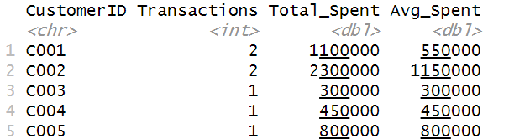

The second customer has the highest total and average spending, however, the average spending is greater than total spending. On the other hand, the first customer’s total spending is greater than his average spending. Customer 3, 4 and 5 have the same total and average spending.

Key takeaway:
Customer 3, 4 and 5 are spending smartly than customers 1 and 2 as shown by the number of transactions.

Time-based Analysis

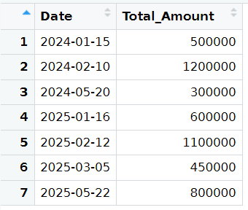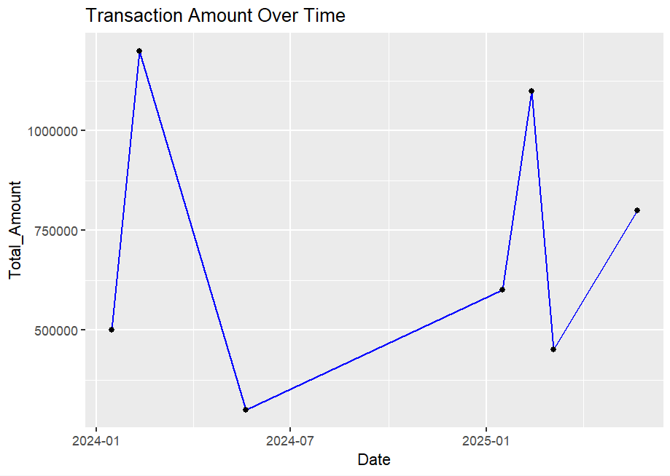
According to the table, there is no linear pattern. The transactions span from 2024 to 2025 and there is no linear pattern. A slight increase in transaction amounts was observed in the later period, particularly among repeat customers. The upward trend may reflect increased transaction activity over time or improved customer engagement.
The line-chart shows a spike in the transaction amount till February 2024 then dropped significantly till June, followed by a steady increase after July till February 2025, then rose again till March 2025 , leading to a decline again.

Visualizations

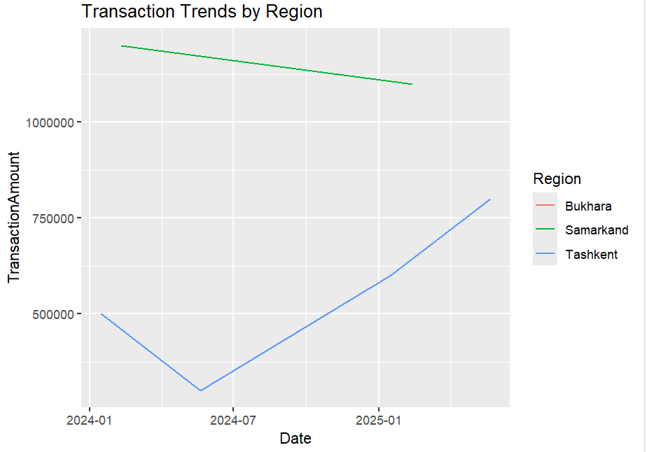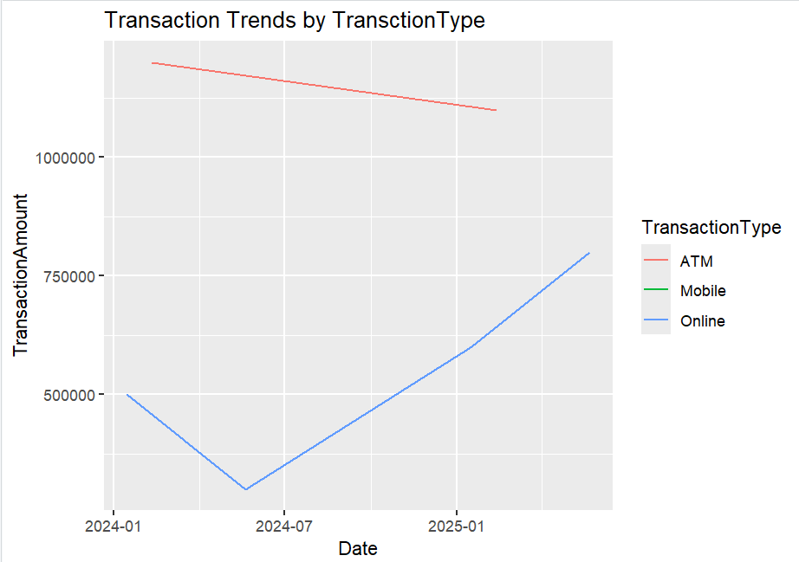
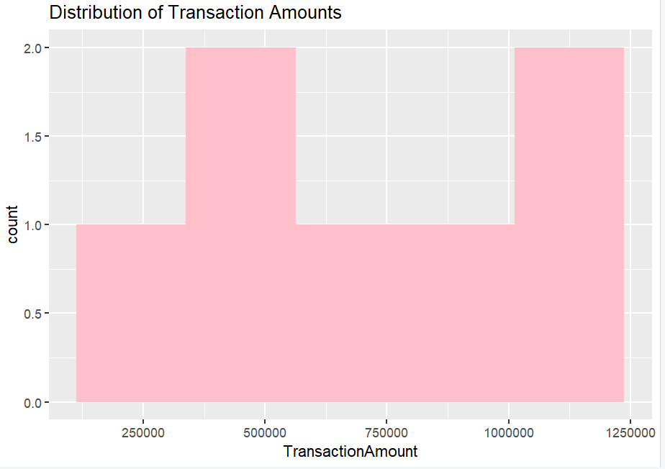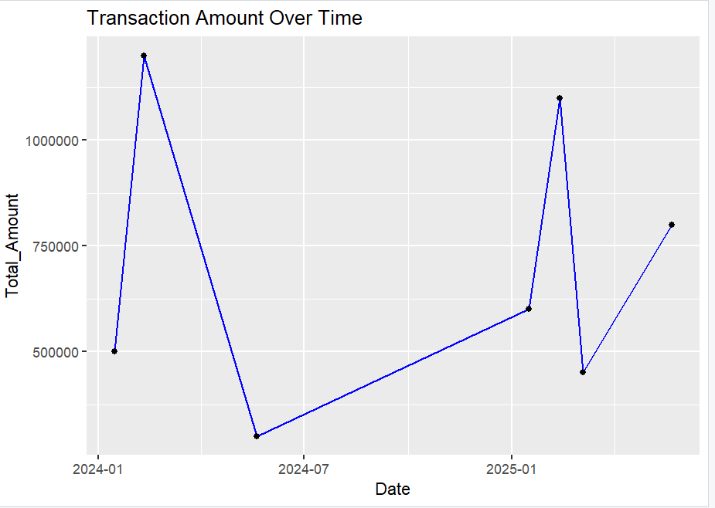

Several visualizations were created using R to support the analysis, including:
- A histogram of transaction amounts
- A line chart showing transaction trend by region
- A line chart of transaction types
- A line plot showing transaction amounts over time
These visualizations enhance interpretability and provide visual confirmation of numerical patterns.

Key Findings

• Online transactions are the most frequent transaction type
• ATM transactions involve higher monetary values
• Tashkent is the most active transaction region
• Repeat customers contribute significantly to transaction volume
• Transaction amounts show a mild upward trend over time

Limitations

- The dataset contains a small number of observations
- Limited regional and customer representation
- Findings cannot be generalized to a larger population
Despite these limitations, the dataset is suitable for demonstrating exploratory data analysis techniques in R, however it can lead to misleading analysis.

Conclusion

This project demonstrates my effective use of R for exploratory data analysis on financial transaction dataset. Through descriptive statistics, grouped summaries and visualizations, meaningful insights were extracted from the transaction dataset. Although the dataset is small, the analysis successfully fulfills the objectives of applying R programming techniques to real-world data.

Appendix
